Anushka Krishnakumar, Lisa Walker, Gavin Bowman, Katrina Gutierrez, Kevin McGrath

***Stage III – Elaboration: Database Model***

Each team will review the specifications with stakeholders to discuss the requirements and scope of the project. All members of the team must actively participate in this review.

Based on the discussions, the team will develop a complete entity- relationship (ER) diagram to model the database. If you are adding to an existing system, show how and where the additional data fits into the original schema. Indicate what changes must be made to the original schema to integrate the new data.

• Show all entities and the relationships between them. Be sure to clearly specify aggregation, composition, specialization / generalization, and multiplicities.

• Show attributes for each entity and relationship (where applicable).

• For each entity, indicate which attribute(s) form the primary key.

**ENTITIES: Attributes**

* **Journalist: JournalID, JName (FName, LName), Publication**
* **Community Member: MemberID, CName(FName, LName), Township**
* **Community Form: FormID, CName, Township, Questions(Category, Summary, Importance, Who’s Affected by Issue, Possible Solutions)**

Map the ER diagram to a relational schema, i.e. show the relations that evolve out of the ER diagram.

Specify the keys and relationships between the relations.

* **Community Member Submits Form (1:N)**
* **Journalist Accesses Form (M:N)**

<https://www.lucidchart.com/invitations/accept/06969d02-1f46-4739-84ea-88f181d1cf50>

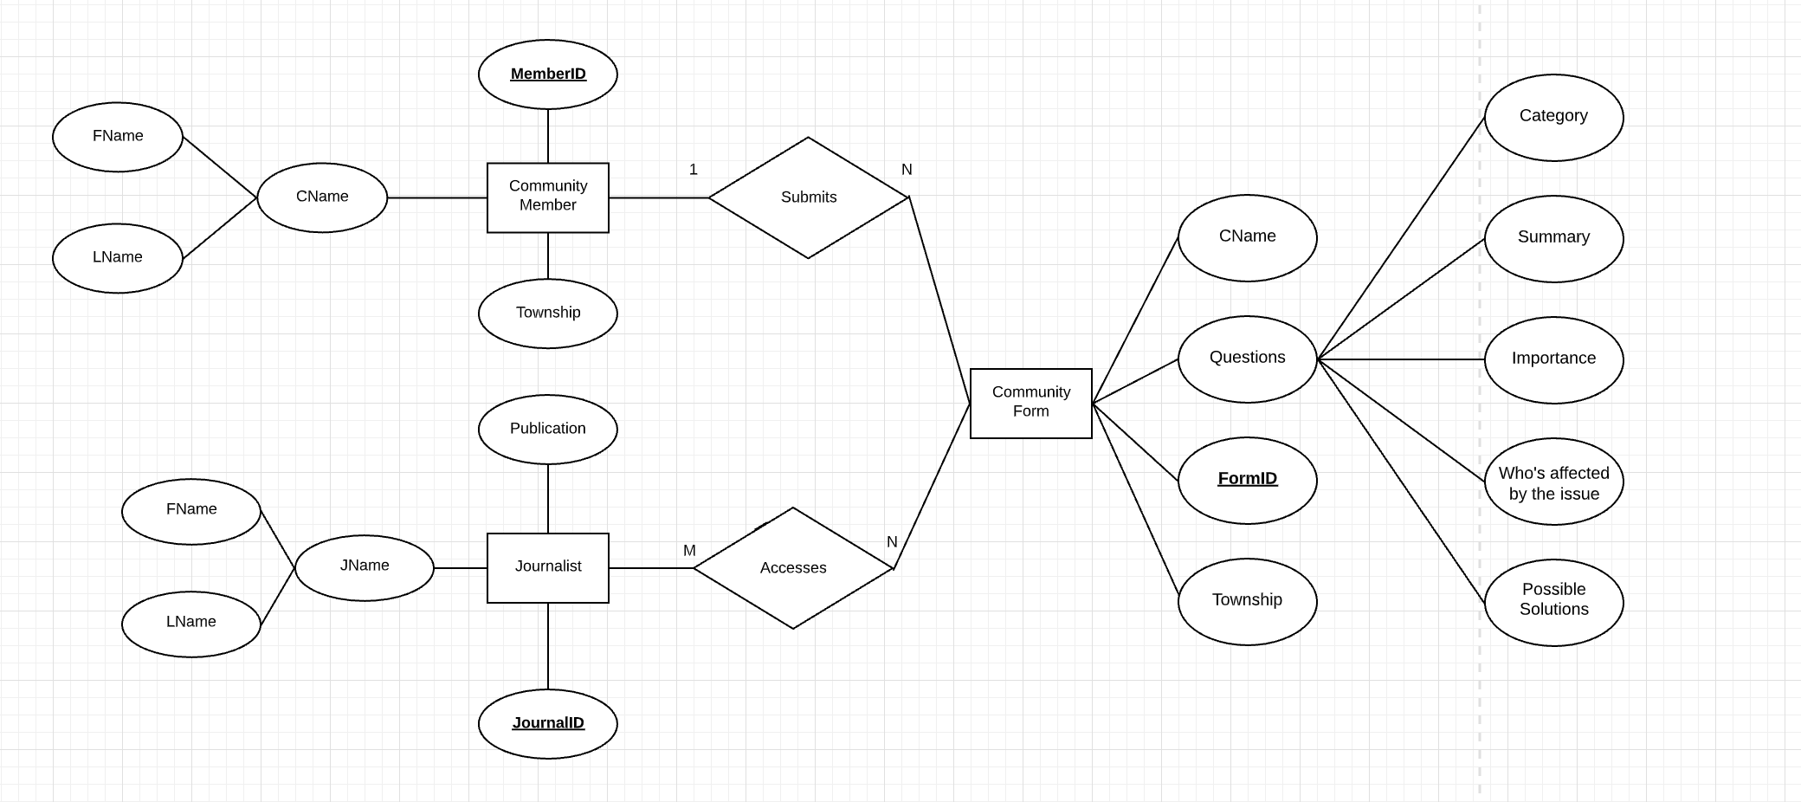

Additionally, based on your research and understanding of the social justice issue, estimate the following:

• We anticipate our database to initially be limited in size based on our resources. We hope to be able to populate it with at least one hundred entries initially. Ideally having one hundred journals available for members to consult will give them the necessary resources to continue to contribute and add to the database.

• Types and average number of searches

* Searching through the database content is predicted to be more useful for journalists than community members. Types of searches we estimate that they would use are keyword searches either by searching the words or a typed out string. String searches would use a stop word search function that selects only keywords that are followed by a stop word (such as *the, an, at, for, from, then*). These queries then search through all user submissions and select where it is most frequently used in the form. Categorical searches may also be implemented for better searching through the forms. If a categorical search is implemented for journalist access only, for example, to find problems in a certain community, then queries will be modified to allow searches that collect attributes that match the search in that column of the database.
* A categorical and keyword search may be also used for community members who want to browse through problems in their communities if we do to implement it.
* The average number of searches we estimate to occur is limited. The number of searches would be from the community members and journalists, which we believe will be around a few searches per member. We do not expect our search queries to back up too much.